**POTICIAN JUDGEMENT : A QUANTITIVE ANALYSIS OF**

**CANDITATES IN THE 2019 LOK SABHA ELECTIONS**

I AM S.JAI PRAKASH. MY TEAM MEMBERS ARE K.ANANTH, S.ESAKKIPANDI,R.MOHAMMED HAKKEEM. POLITICAL JUDGEMENT IS THE NAME OF MY PROJECT.

INTRODUCTION:

A QUANTITIVE ANALYSIS OF CANDITATES IN THE 2019 LOK SABHA ELECTIONS AND IDEAS ABOUT SAYS THINK DOES AND FEELS IN THE BRAINSTORM MAP. THEN CREATE EMPATHY MAP AND OUR OWN IDEAS CREATION A GRAPH ABOUT OUR PROJECT IN USING BY OUR IDEAS. NOW WE SEE OUR BRAINSTORM AND EMPATHY MAP.THEN NOW ABOUT OUR PROJECT IDEAS.

DEFINITION:

EMPATHY MAP

BRAINSTORM

EMPATHY MAP:

EMPATHY WAS COLLECTED BY OUR TEAM MEMBERS OWN IDEAS AND THINK ABOUT OUR POTICIAN JUDGEMENT.

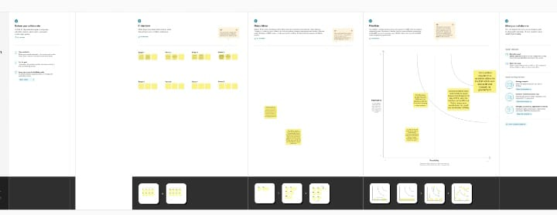

BRAINSTORM:

IN THIS BRAINSTORM MAP WE GIVE OUR PROJECT DEFINITION ABOUT OUR PROBLEM IN THIS PROJECT. THEN SAID OUR OWN IDEAS FOR TEAM MEMBERS AND GAVE OUR GROUP DISSCUSSION IDEAS AND SAID A PROBLEM SOLUTION GRAPH.

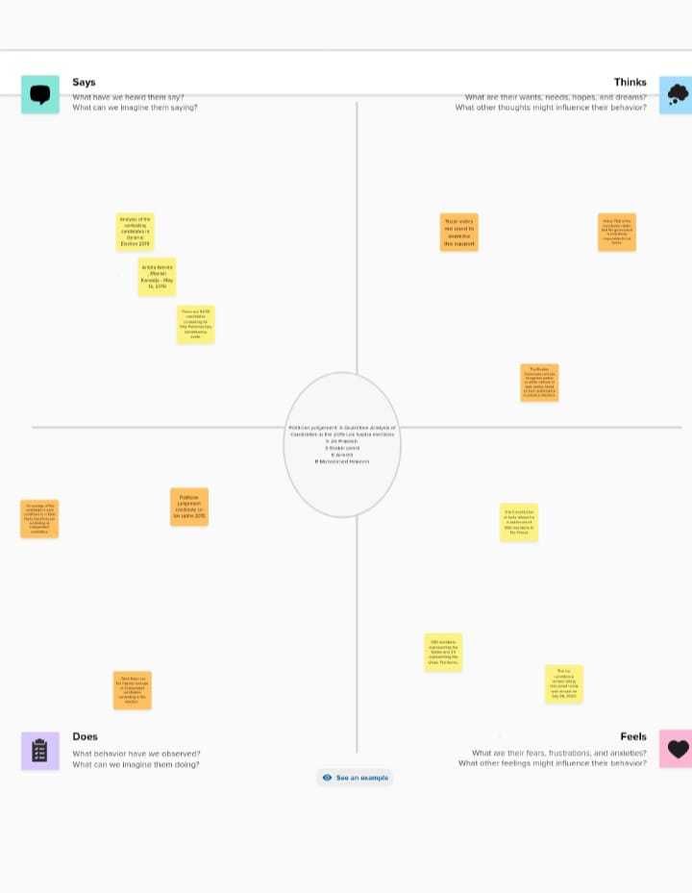

DASHBOARD:

IN THIS DASHBOARD WE COLLECT OUR DOING VISUALITATION SHEET IN OUR DASHBOAED THEN SET ALL SUITABLE VALUES FOR OUR PROJECT

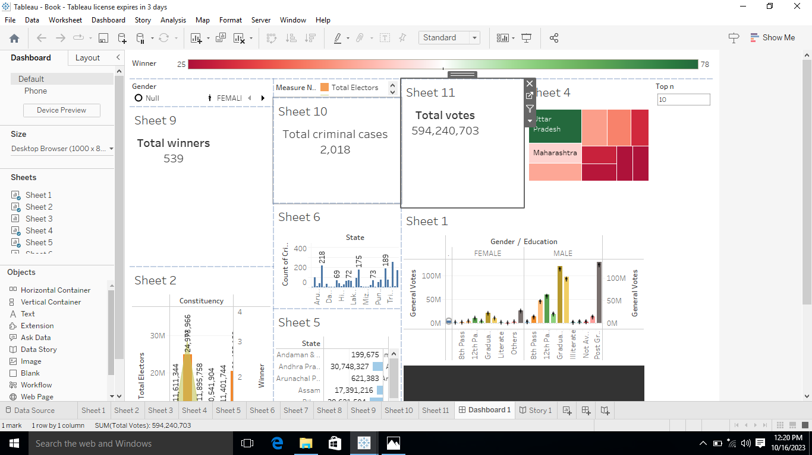

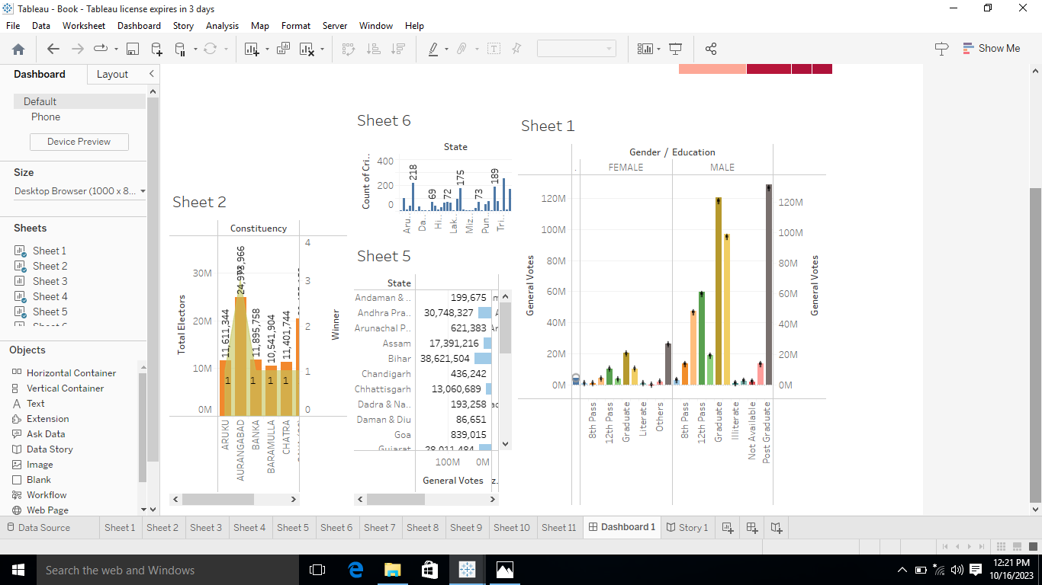

STORY:

IN THIS STORY WE SAID OUR DATA VISUALIZATION SHEETS GIVES ONE BY ONE WITH SUITABLE CAPTION. LIKE FIX OTHER DATA VISUALIZATION SHEETS.

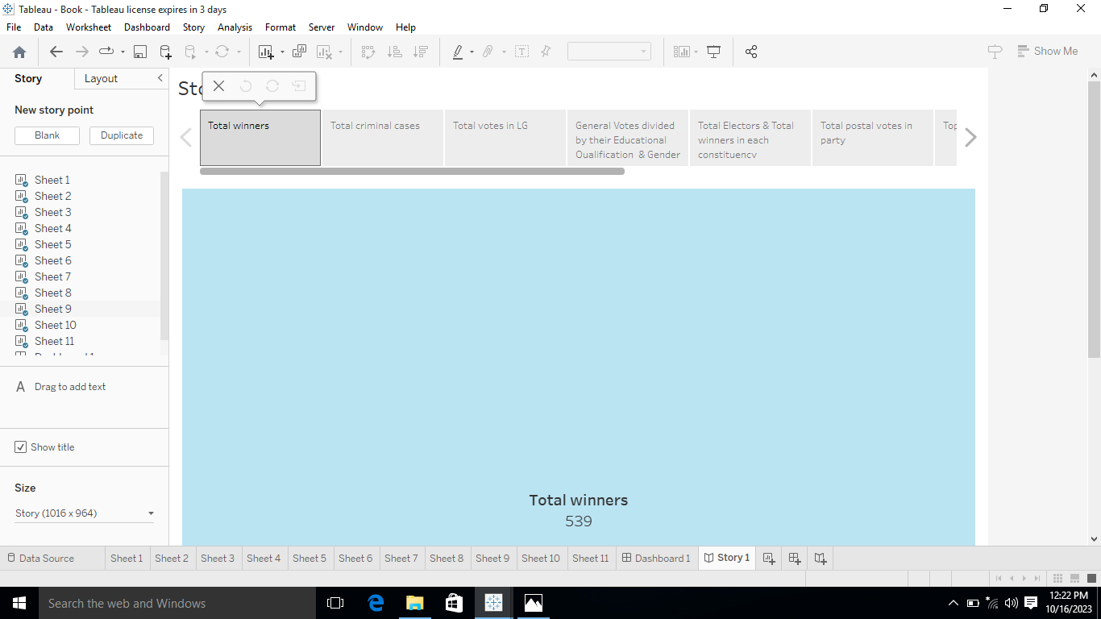

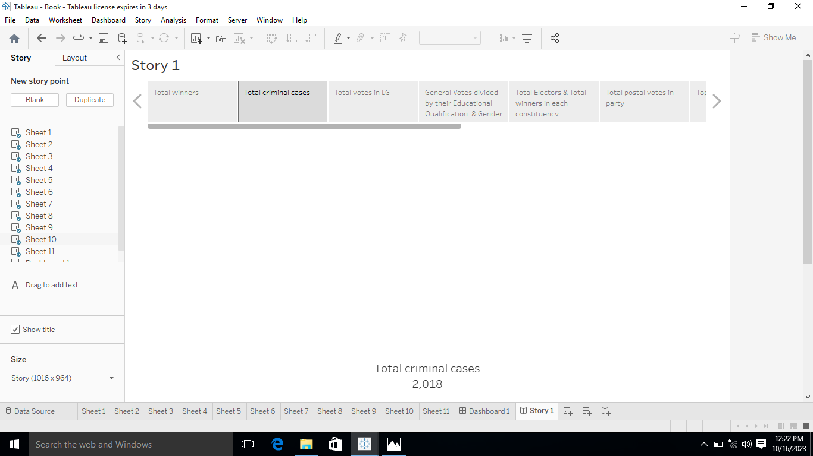

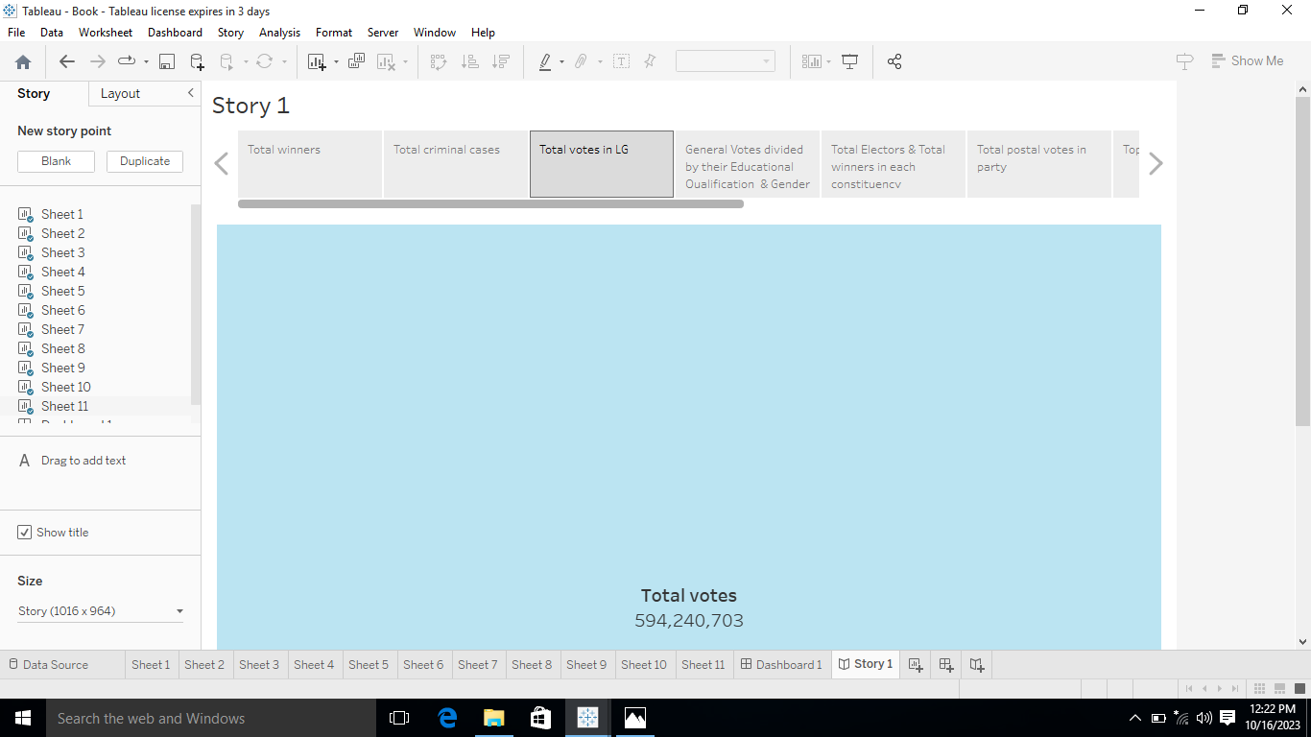

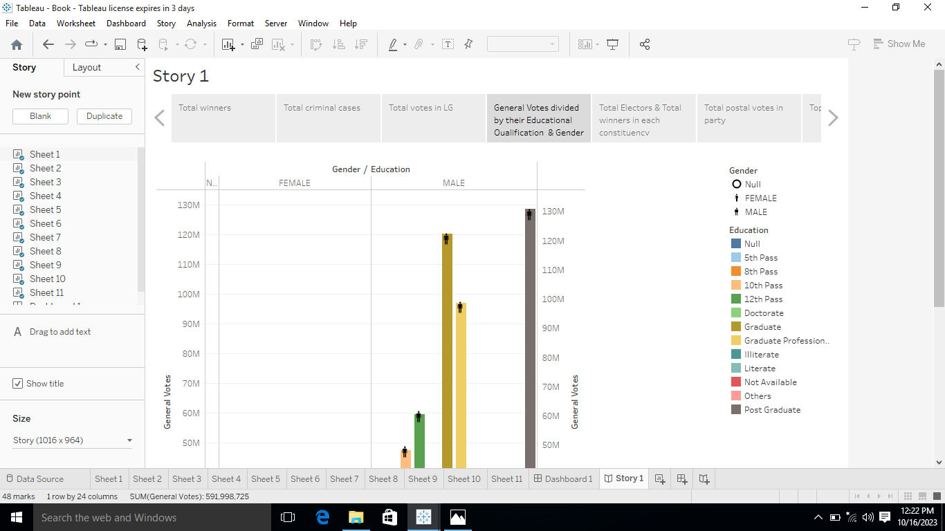

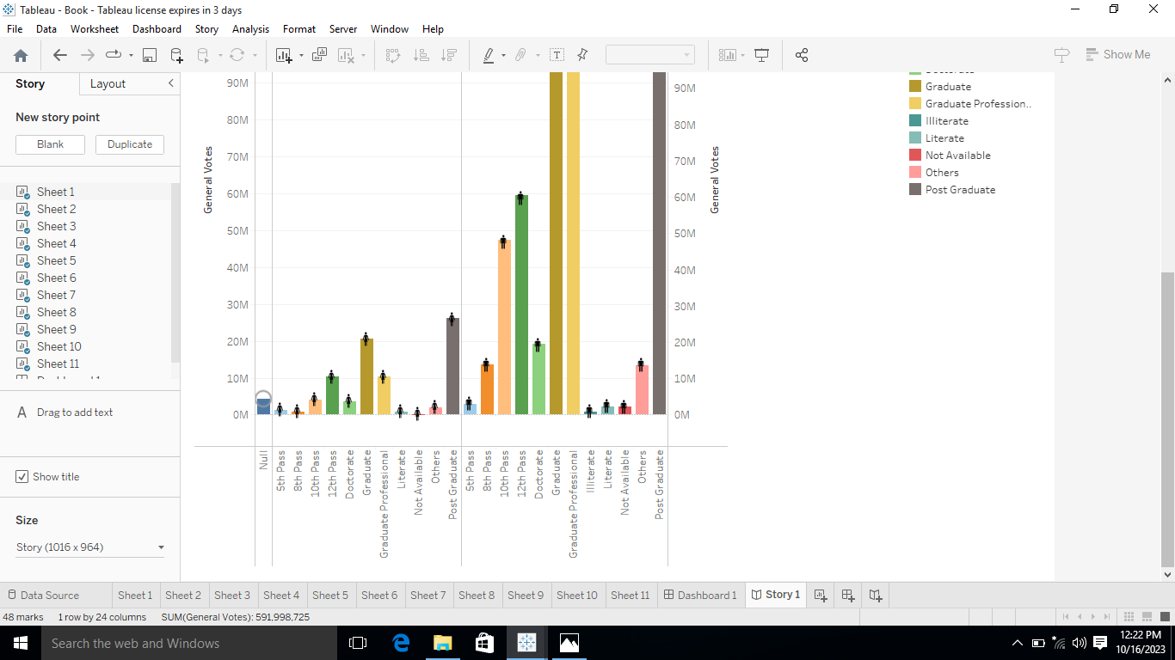

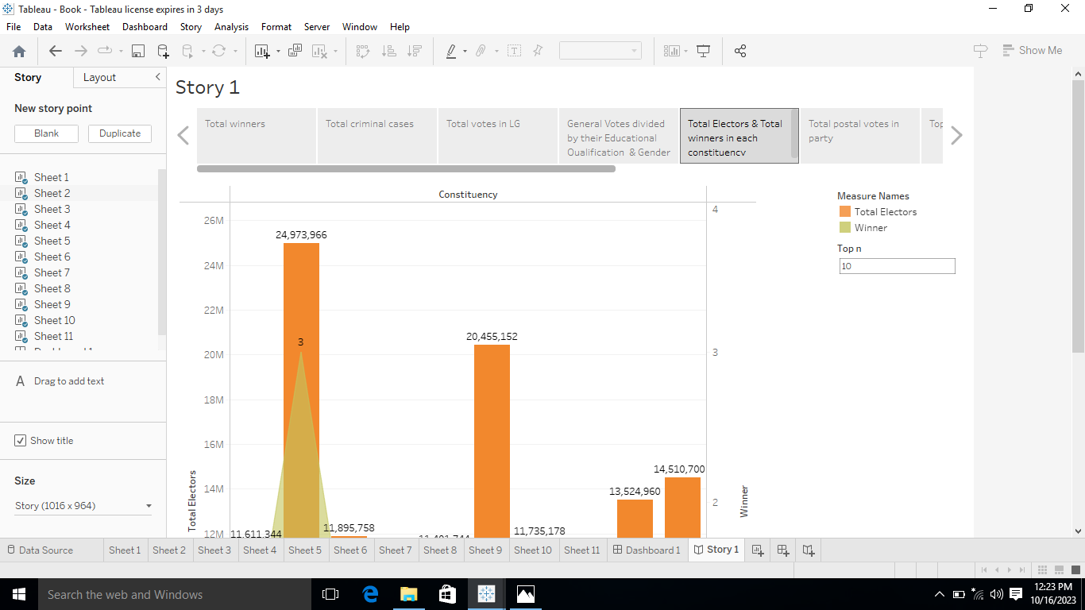

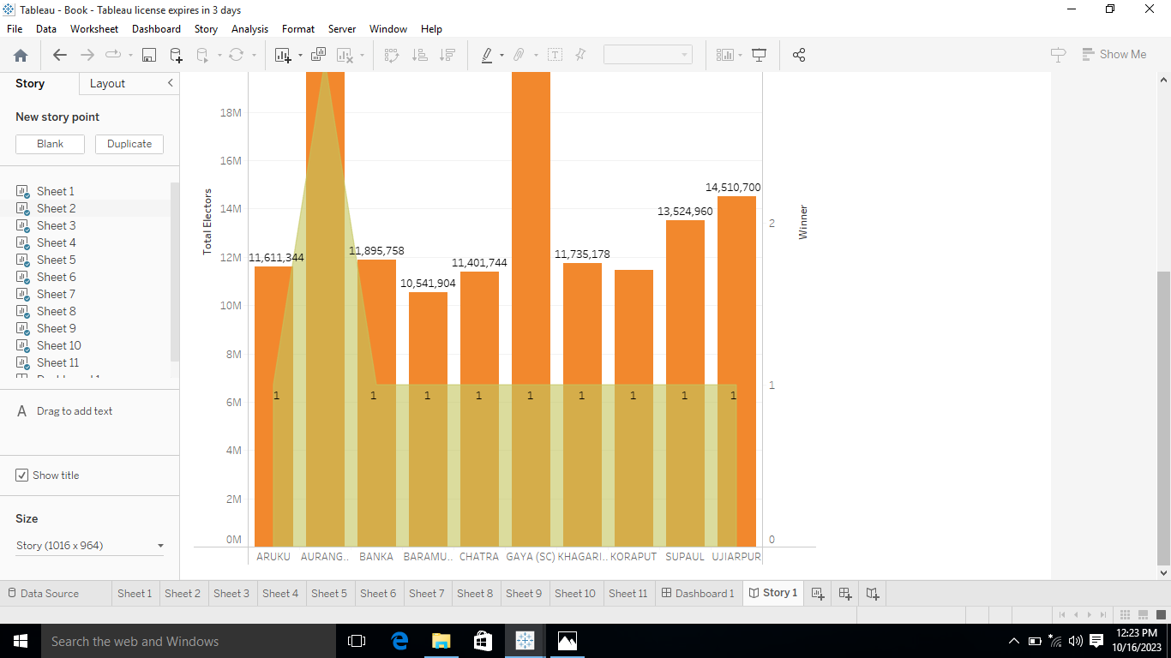

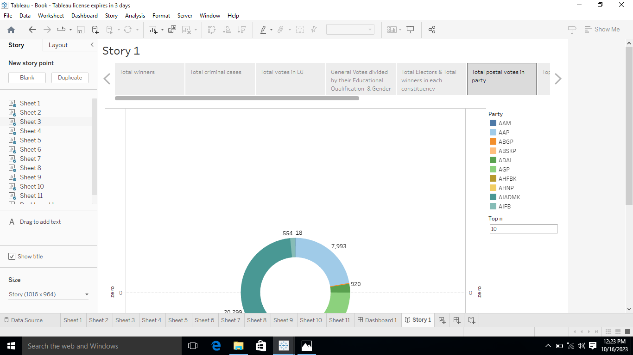

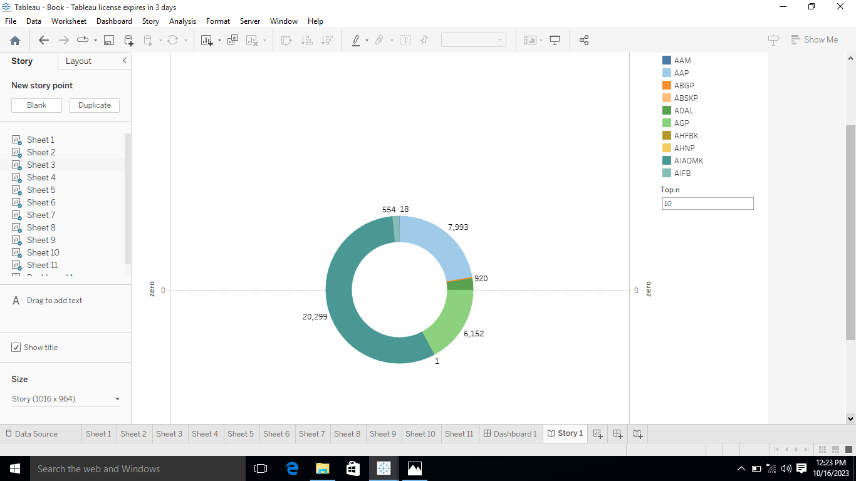

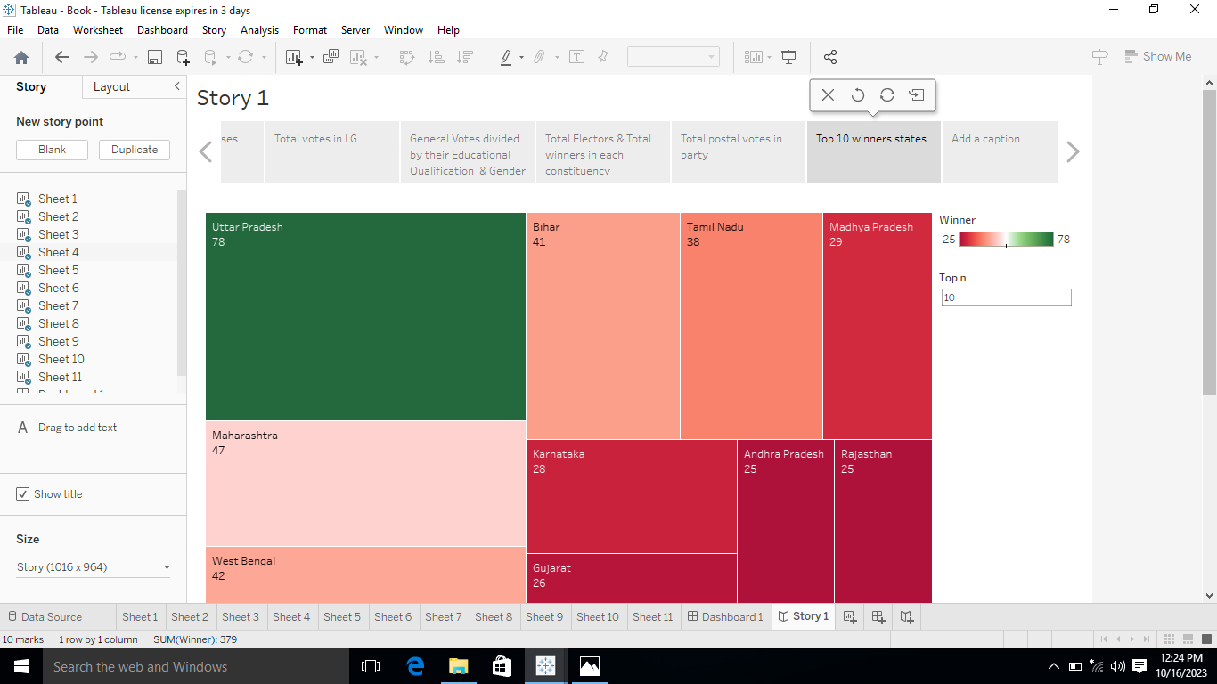

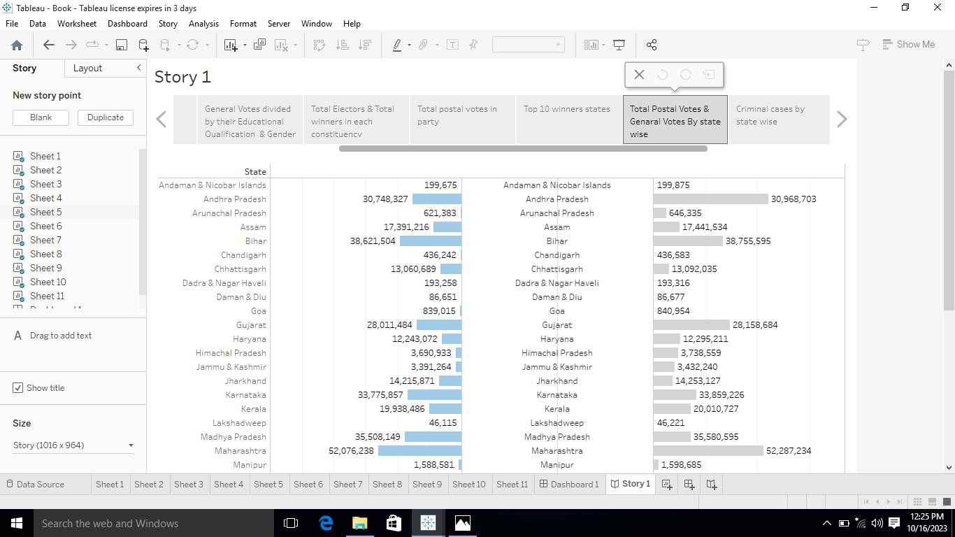

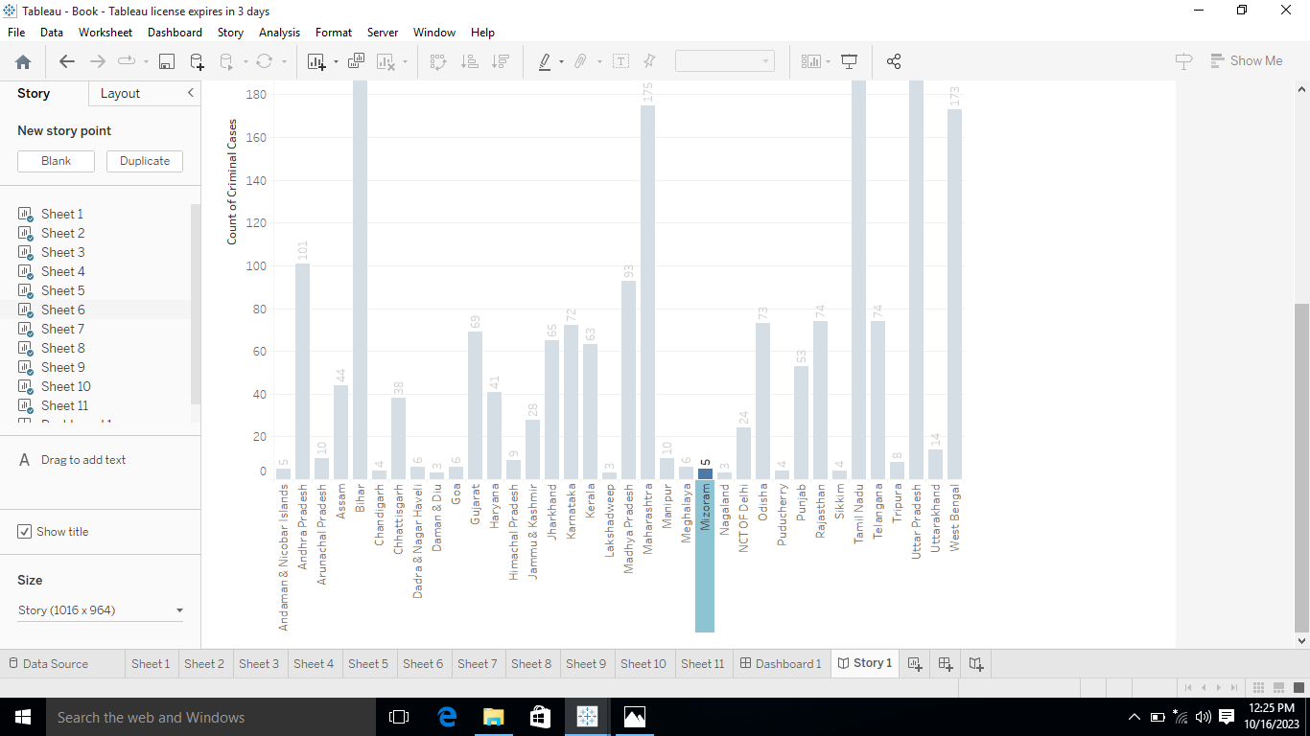

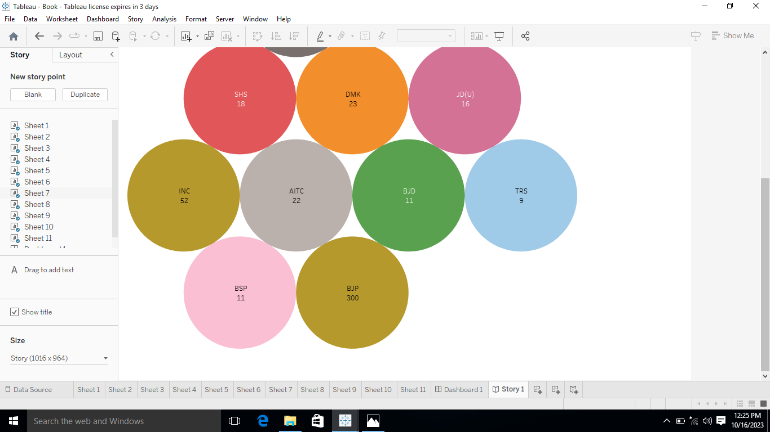

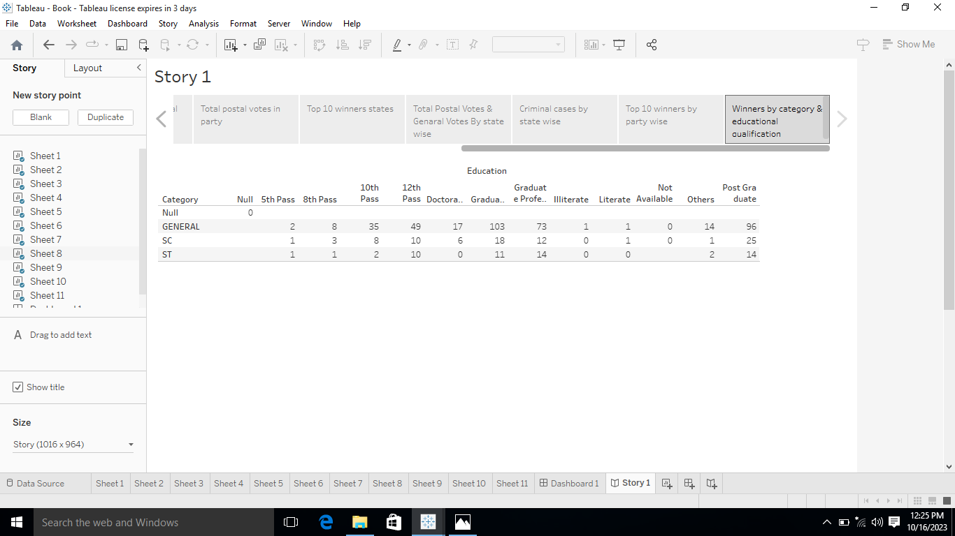

CONCLUSION:

IN THIS POLITICAL JUDGEMENT PROJECT WAS SAYS ABOUT : A QUANTITIVE ANALYSIS OF CANDITATES IN THE 2019 LOK SABHA ELECTIONS AND HAVE MANY ETHICS OR STANDARDS PROGRAMMES FOR POLITICIANS MAY WELL BE SUBJECT TO SUCH OBJECTIONS. THIS ALL THE CONTENTS ABOUT POLITICAL JUDGEMENT.